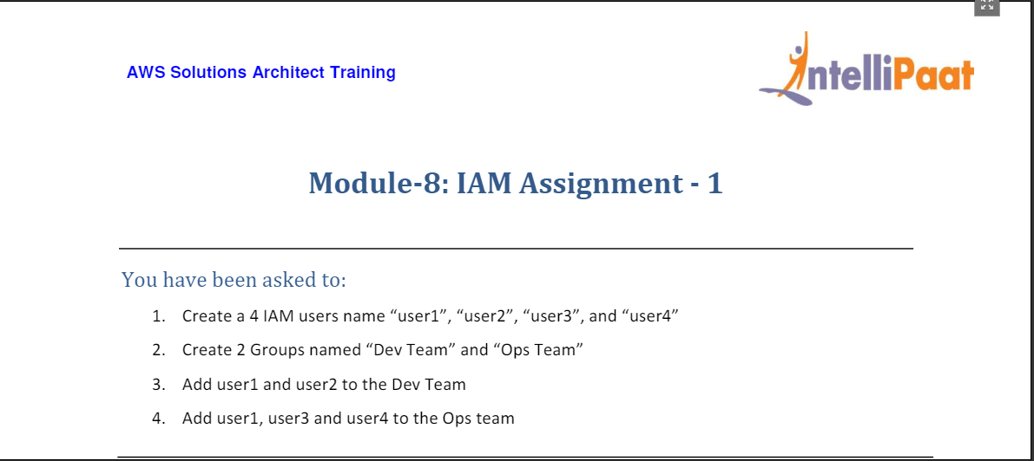

1. From the Console home choose IAM service

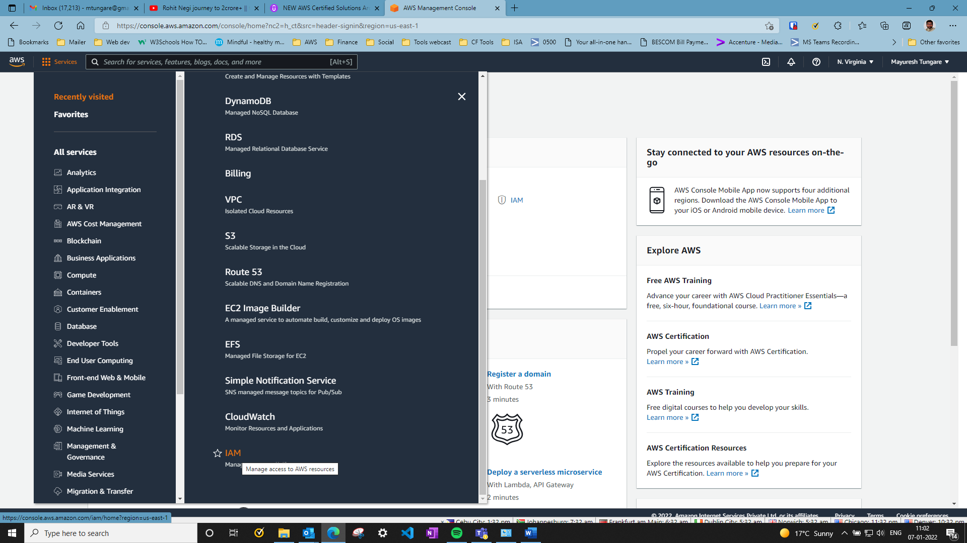

1. On IAM dashboard, select users on the left as shown below.

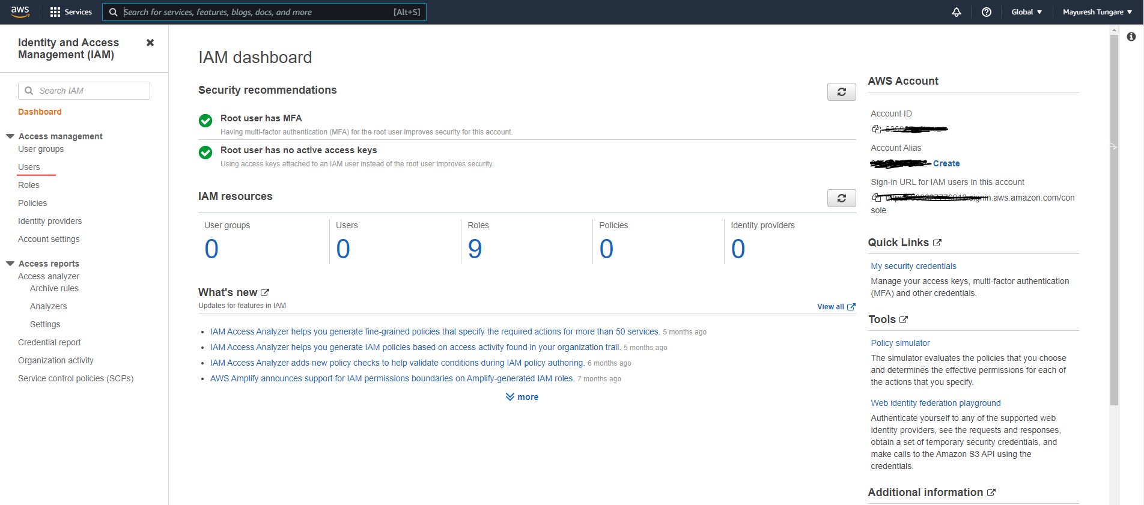

1. Click on ‘Add users’ on right to start adding users as below as shown below:

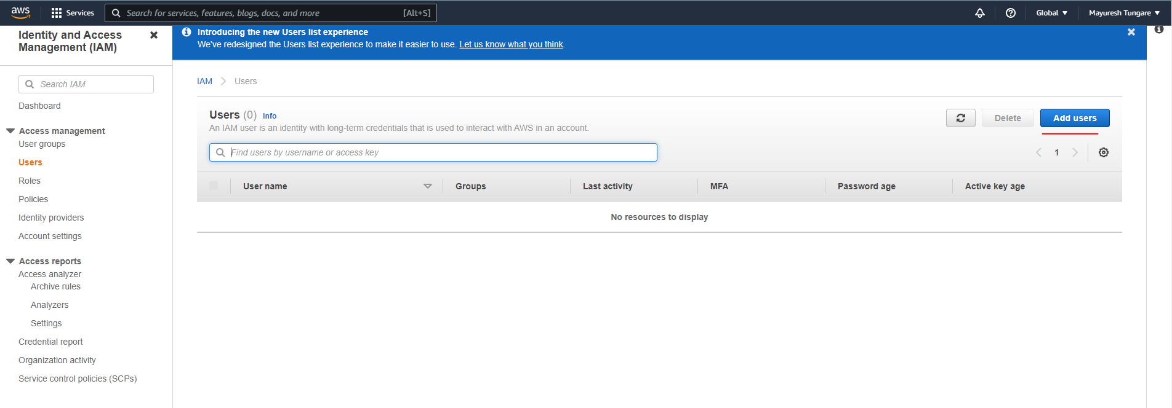

1. Add user1, user2, user3 and user4 as shown below:

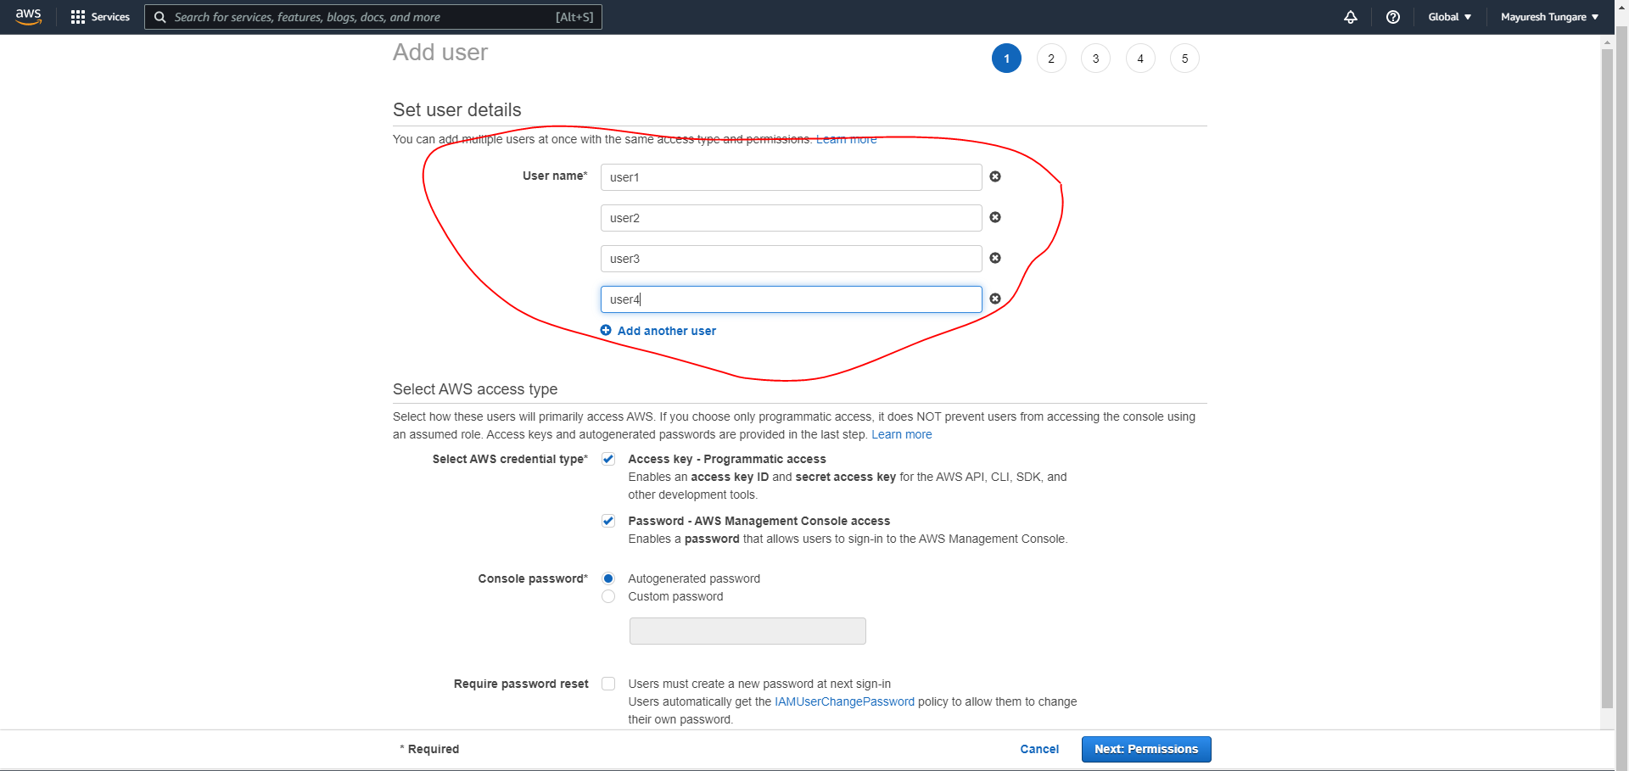

1. As can be seen below, all the users have now been created:

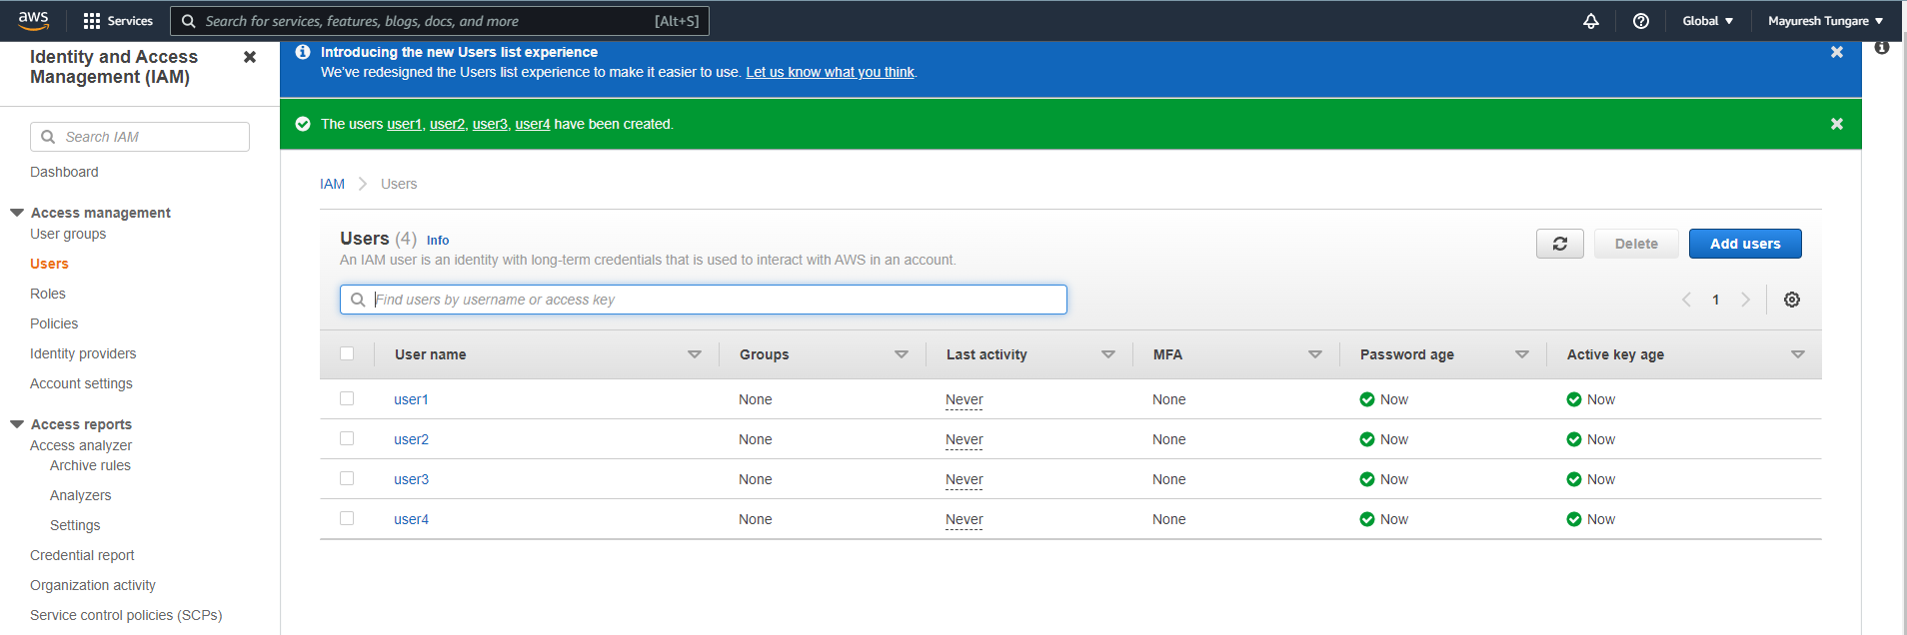

1. For the next step, we select user groups. Currently no user groups are created. Therefore, we use ‘Create group’ to create two groups: ‘Dev Team’ and ‘Ops Team’ as shown below.

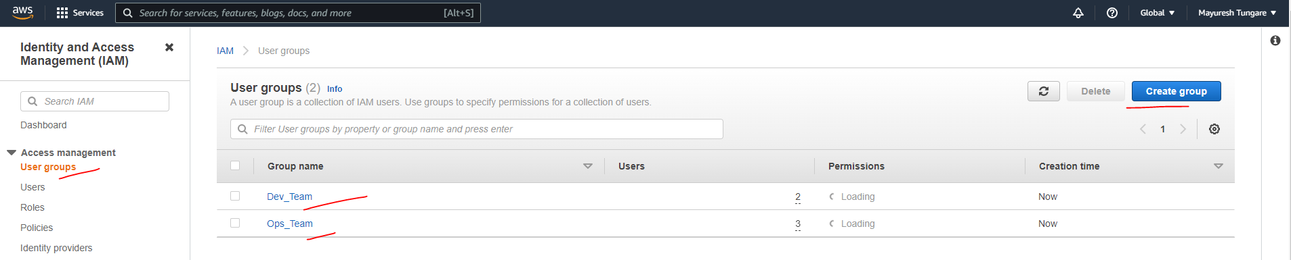

1. In Dev_team, we have added user1 and user2.

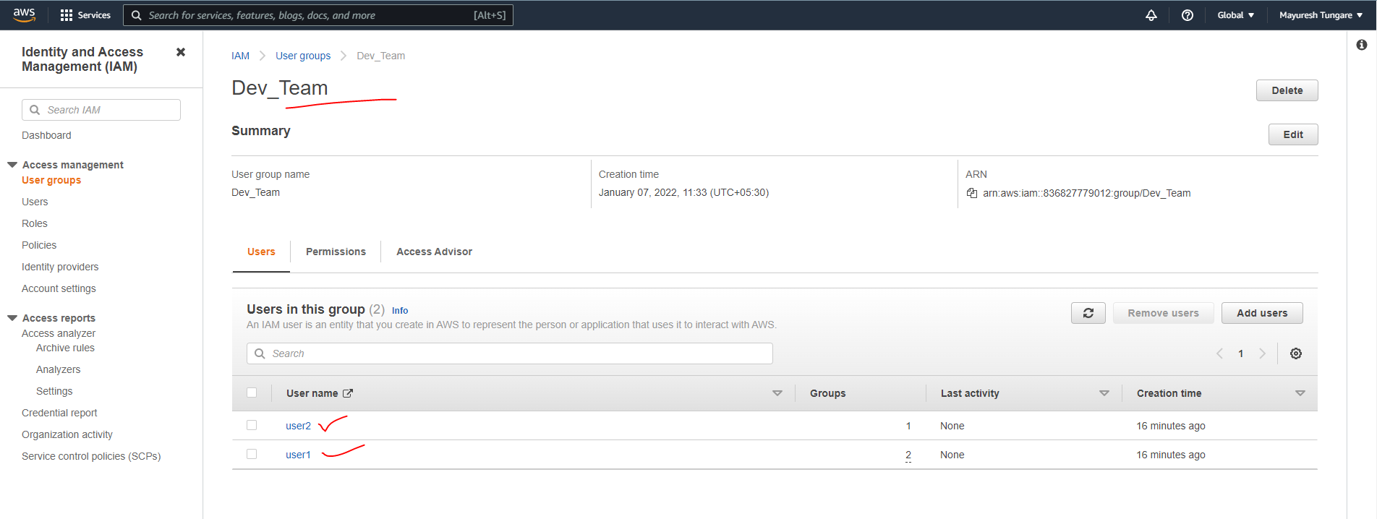

1. In Ops_team, we have added user1, user3 and user4.

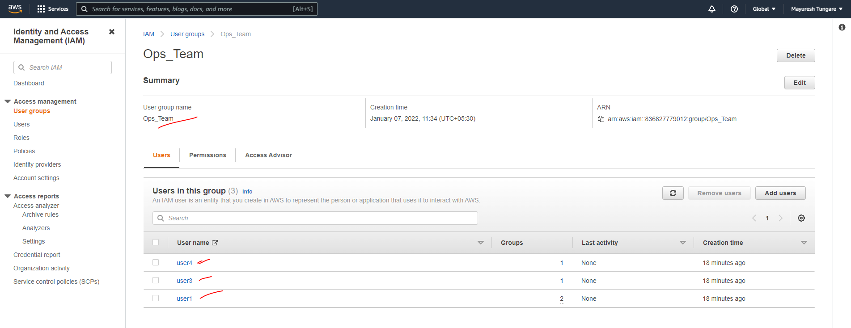

1. Thus, this assignment is now complete.